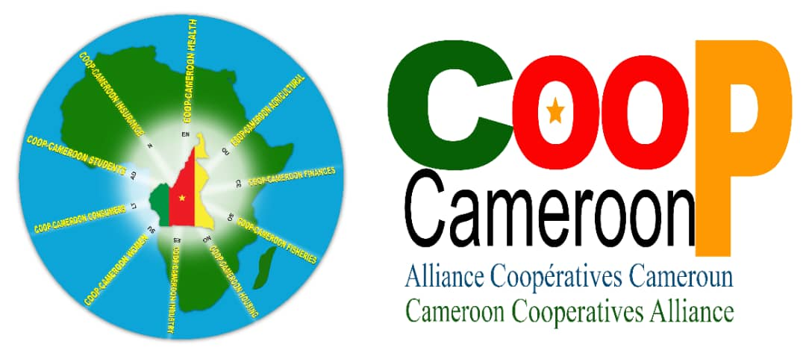

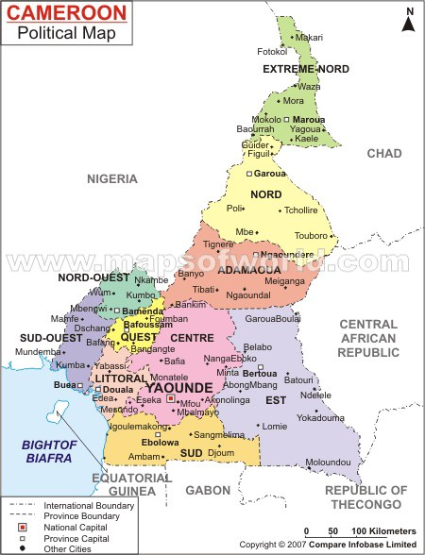
Cooperation with the authority in charge of the register and technical supervision of cooperatives in Cameroon : The Miniter of Agriculture and Rural Development and the Minister Delegate in charge of Rural Development (MINADER)

Cooperation with the Cameroonian Bank of Small and Medium Enterprises (PC-PME). Working session with Madam the Director General of the public capital Bank of Cameroonian Government
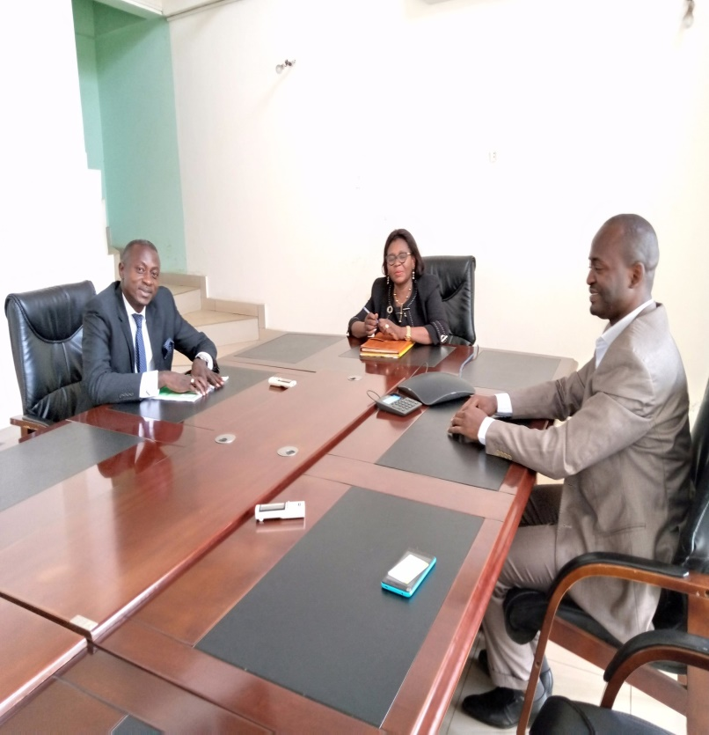

Working session with the heads of the United Nations and Decentralized cooperation Directorate of the the Ministry of External Relations (MINREX)

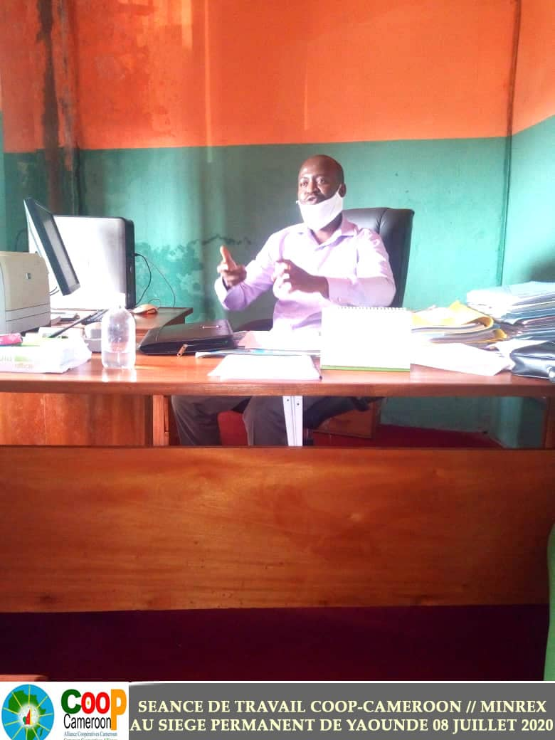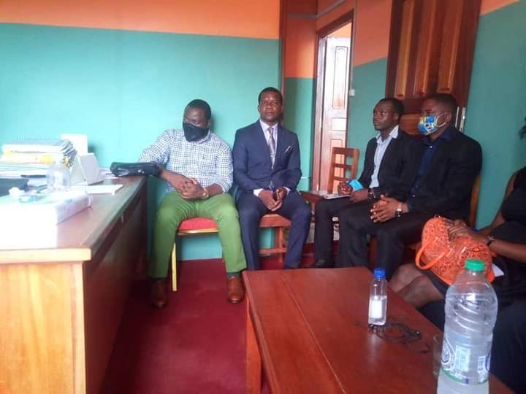
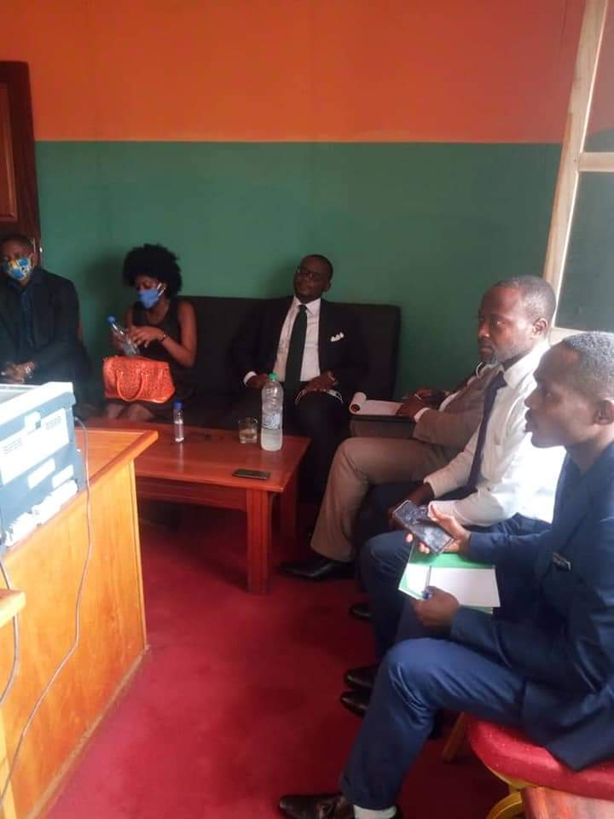
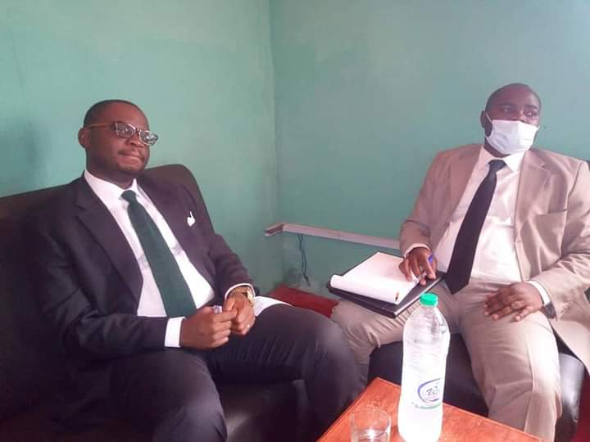
DECENTRALIZED COOPERATION

Synergy of cooperative action with the Mayor of the Municipality of MEYOMESSALA in the South region (Municipality of origin of the president of the Republic of Cameroon)
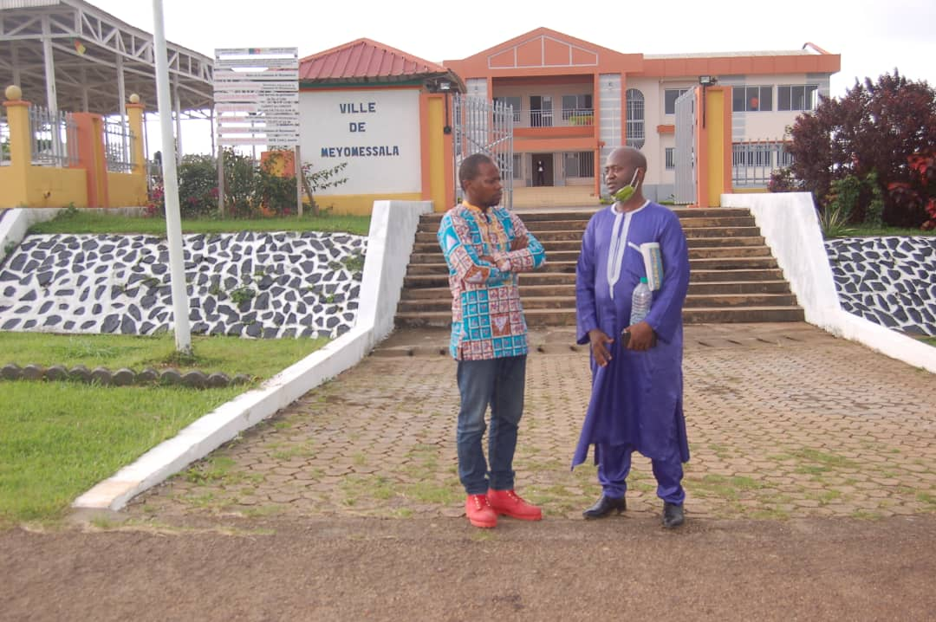
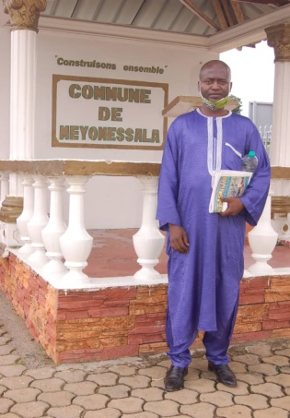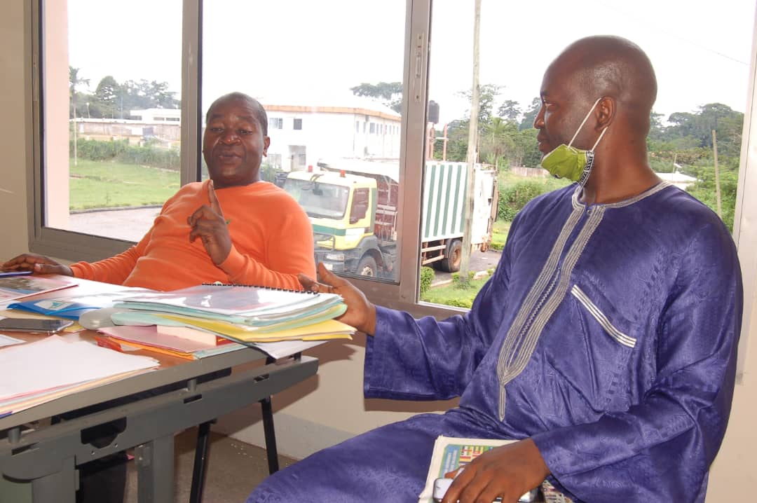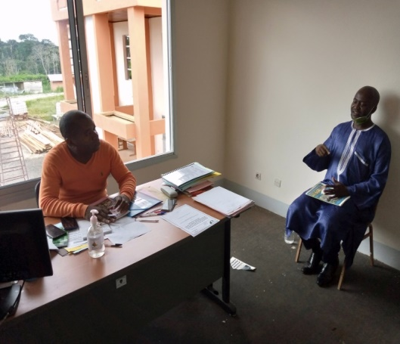
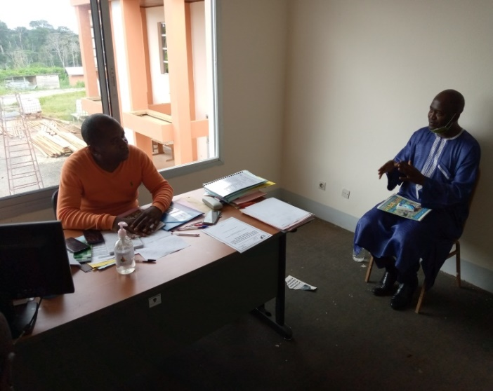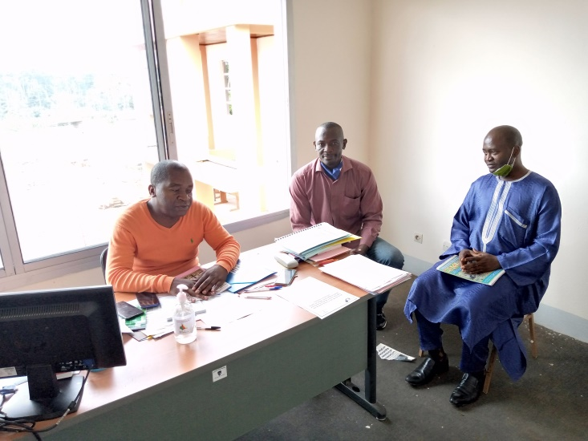
Synergy of cooperative action with the outgoing Mayor of the Municipality of DIBANG in the Center region (Municipality of origin of the national president and founder of Cameroon Cooperative Alliance (COOP-CAMEROON))

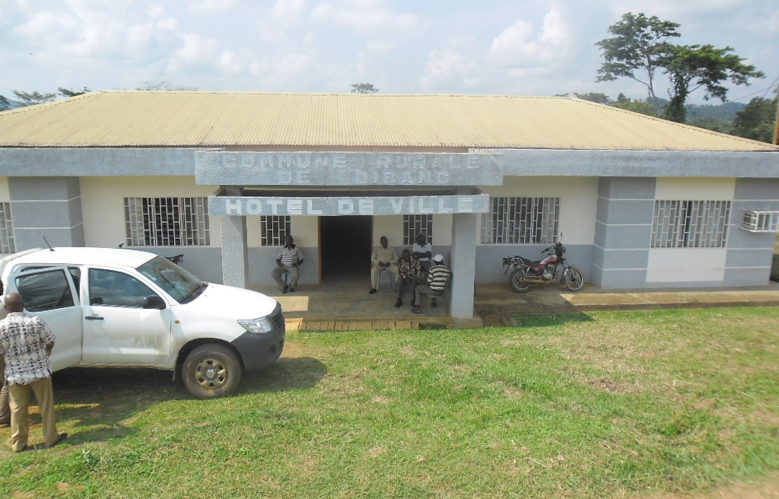
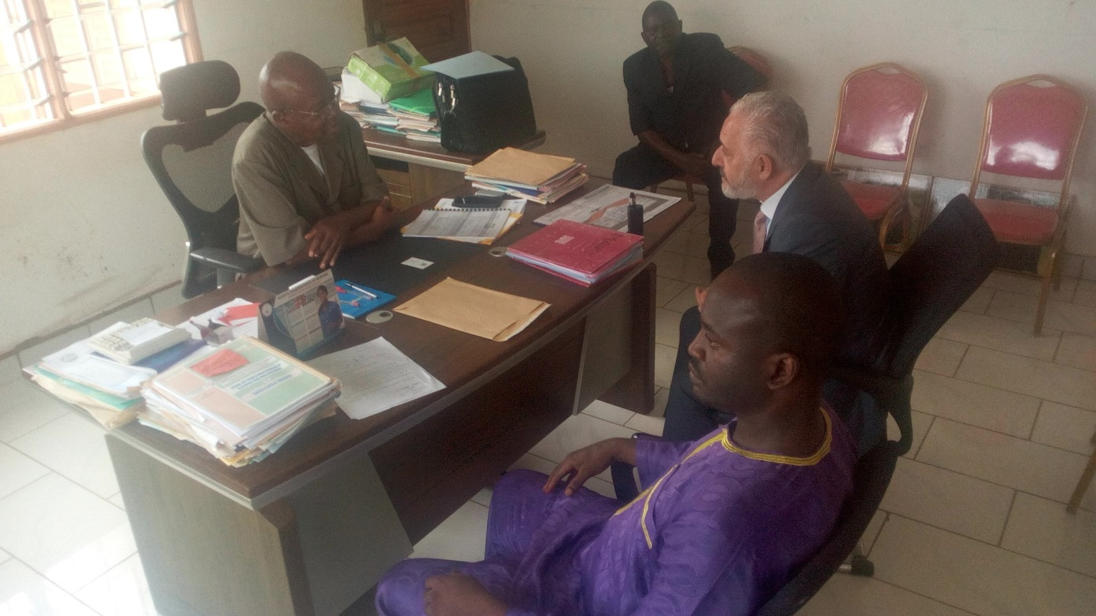

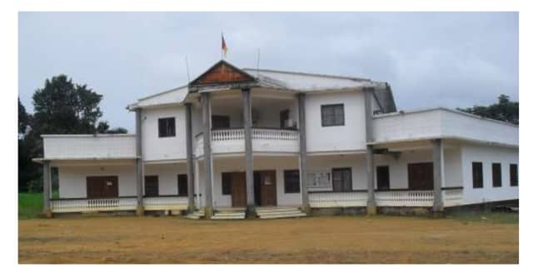
Synergy of cooperative action with the Mayor of the Municipality of MASSOCK SONG LOULOU in the Coastal region (Municipality that houses one of the largest hydroelectric in Cameroon)
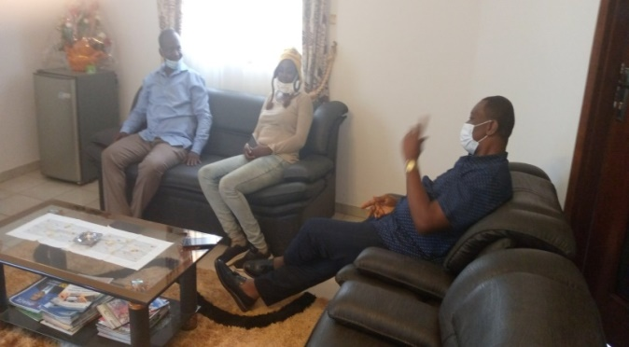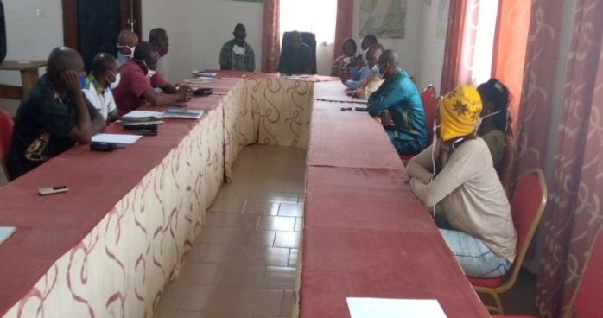
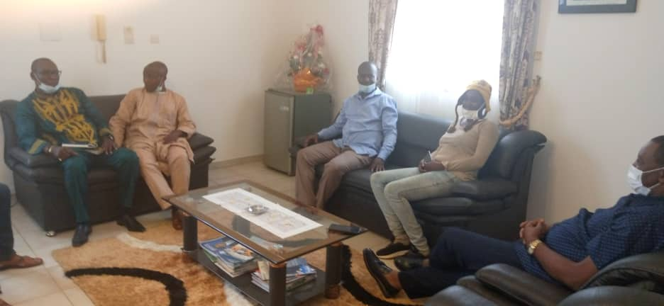

Future cooperative action for the supervision of the indigenous Baka people of Municipality of MOLOUNDOU in the eastern region.

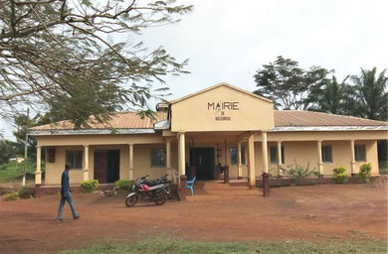
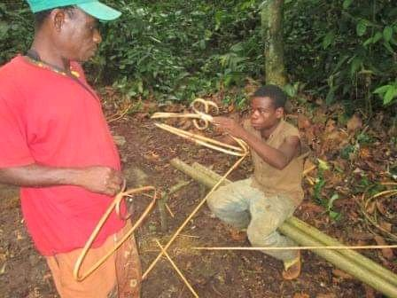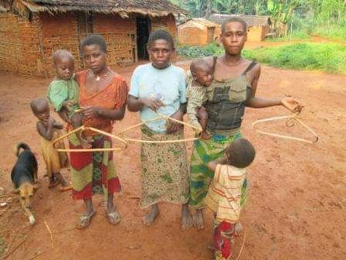

SECTORAL ORGANIZATIONS OF INTERNATIONAL COOPERATIVE ALLIANCE
WHICH HAVE ALREADY ACCREDITED COOP-CAMEROON

